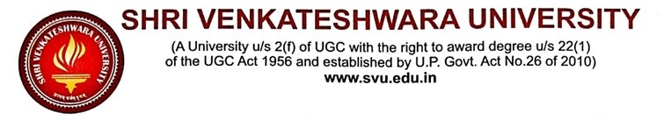
EMPLOYER FEEDBACK ON CURRICULUM
(Academic Session 2023-24)
Dear Employer,
SVU, Gajraula is grateful to you for employing our graduates with your renowned organisation. We would appreciate if you could spare some time to fill out this feedback form, which will help us improve the curriculum and give better graduates to industry.
Name of Respondents
Designation of Respondent
Associated Organization
Mobile/Email ID of Respondent:
SCALE OF FEEDBACK
Excellent | Very Good | Good | Fair | Need Improvement
5 | 4 | 3 | 2 | 1
FEEDBACK QUESTIONS
Q1. How long SVU alumna working in this organisation?
- Less than 6 months
- More than 6 months but less than one year
- Between one and two years
- More than two years
Q2. Rate the employee's (SVU students') performance on the following characteristics:
S. No. | Particulars | Excellent | Very Good | Good | Fair | Need Improvement
 |  | 5 | 4 | 3 | 2 | 1
1. | Fundamental Competency
2. | Depth understanding of the discipline
3. | Communication skills
4. | Research aptitude
5. | Proficiency in technical aspects
6. | Creative thinking
7. | Leadership qualities
8. | Professional values and ethics
Q3. Rate the overall performance of our student who works with you.
- Excellent
- Very Good
- Good
- Fair
- Need Improvement
Any suggestions to improve student and curriculum quality.
…………………………………………………………………………………………………………………………………………………………………………………………………………………………………………………………………………………………………………………………………………………………………………………………………………

