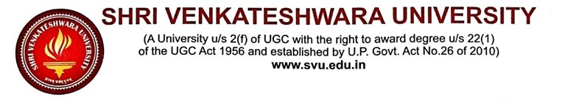
ALUMNI FEEDBACK FORM ON CURRICULUM
(Academic Session 2023-24)
Dear Alumni of SVU, Gajraula
It brings us great pleasure to reconnect with you. We hope you are excelling in your career. We would appreciate your valuable time in providing feedback on the curriculum that you have studied in order to enrich it further.
Name of Alumni
School/College
Program Completed
Programme Completion Year
Currently Working | Yes:
 | No:
Designation
Organization Name
Contact No./ Email Id
SCALE OF FEEDBACK
Thank you for taking the time to offer feedback. Your feedback is valuable to us. Please grade your experience according to the following scale:
Excellent | Very Good | Good | Fair | Need Improvement
5 | 4 | 3 | 2 | 1
FEEDBACK QUESTIONS
S. No. | Question | Excellent | Very Good | Good | Fair | Need Improvement
 |  | 5 | 4 | 3 | 2 | 1
1. | Curriculum contains more relevant and interesting subjects.
2. | The order of the units/ content are well organized.
3. | Curriculum provides sufficient choice in selecting courses.
4. | Rate the balance of theory and practical skills in curriculum
5. | Rate sufficiency of curriculum content and its regular updating as per the demand for employability
6. | Research and internships help in enriching knowledge and skills that can be applicable in the job/ profession
7. | Rate the curriculum in terms of professional ethics and values
8. | Overall satisfaction with the programme that met your expectations
Any suggestions for curriculum enhancement and enrichment
……………………………………………………………………………………………………………………………………………………………………………………………………………………………………………………………………………………………………………………………………………………………………………………………………………………………………………………………………………………………………………

